Shrinkage correlation: AUDUSD and USDJPY
Method 08 / eight-major panel / delta = 0.2 and Ledoit-Wolf / Alpari D1 full available history

Study setup
Logical pair: AUDUSD , USDJPY
Broker symbols: AUDUSD_i , USDJPY_i
Snapshot: 2026-11-03_majors_alpari_D1
Timeframe: D1
Common eight-major panel window: 1999-01-06 to 2026-11-02 (UTC bar dates)
Panel matched return count n: 7127
Dropped unfinished last bar dated 2026-11-03 UTC after a tick-volume check against the prior complete day.
Fixed shrinkage: delta=0.2, mu=3.9170889e-05 (mean of diag(S))
Ledoit-Wolf estimated delta: 0.0042157642
Panel symbols: EURUSD, GBPUSD, AUDUSD, NZDUSD, USDJPY, USDCHF, USDCAD, EURGBP
Complete matched rows (Excel): AUDUSD-USDJPY_Shrinkage_D1.xlsx
Complete matched rows (HTML table): AUDUSD-USDJPY_Shrinkage_D1_data.html

Method carried forward
Shrinkage blends the sample covariance matrix S of matched daily log returns of close, ln(close_t / close_t-1), toward a simple target, then converts the shrunk covariance into correlations. Quotes are not inverted. This experiment builds one common calendar across all eight majors, forms S with the unbiased n-1 divisor, then reports two shrinkage specs: fixed delta = 0.2 with mu equal to the average sample variance (mu * I target), and sklearn Ledoit-Wolf with its estimated delta. Pair reports pull rho_ij from those panel matrices. Same-panel Pearson r is a side check only. Shrinkage improves conditioning; it is not a cause, not a lead, and not a trading signal.

Results
pearson_r | rho_02 | rho_LW | rho_02_minus_r | rho_LW_minus_r | delta_LW
-0.086373 | -0.071268 | -0.086063 | 0.015105 | 0.00031 | 0.00421576

Conclusion
Over the common 7127-day eight-major panel for AUDUSD and USDJPY (broker quote directions unchanged), fixed-delta shrinkage correlation at delta=0.2 is -0.0713 (negative, weak linear link in this sample). Ledoit-Wolf rho is -0.0861 with estimated delta=0.004216. Same-panel Pearson r is -0.0864 (rho_02 minus r = 0.0151; rho_LW minus r = 0.0003). This does not establish cause, lead-lag, or a lasting trading rule.

Charts
Daily closes
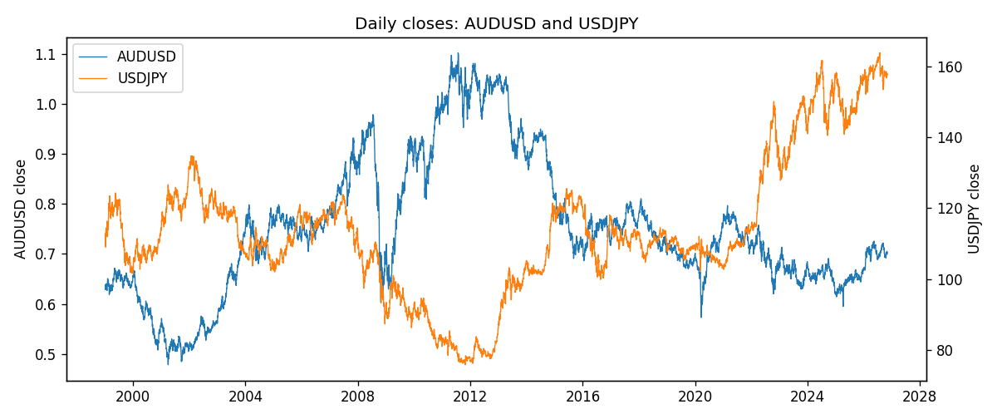
Daily log returns
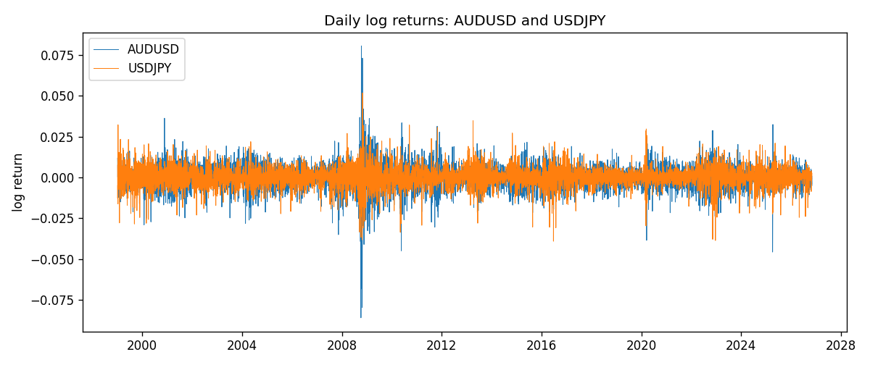
Log-return scatter
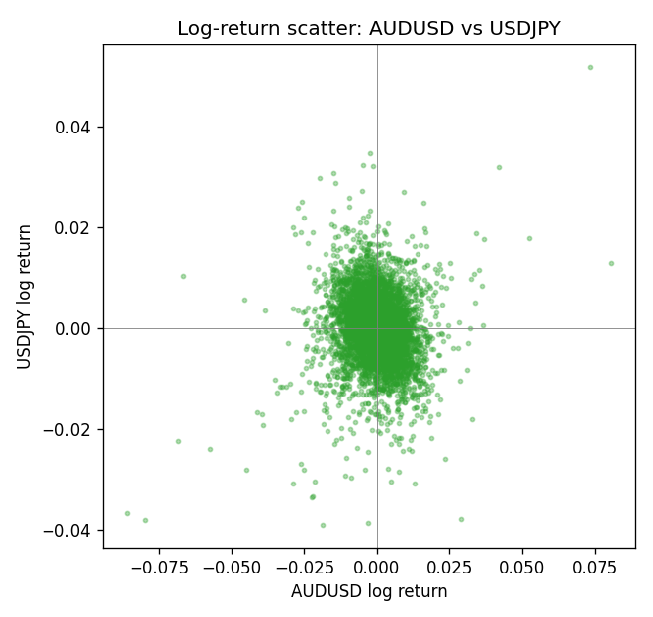

Data report
Every panel row for this pair slice is stored in the sibling Excel workbook named AUDUSD-USDJPY_Shrinkage_D1.xlsx. Full-panel covariance and correlation matrices are saved once under outputs/ as CSV files. Embedding all rows as a Word table is impractical at this length; the Word file holds the column list, column summaries, and the first and last 15 matched rows.
Columns: time, AUDUSD_open, AUDUSD_high, AUDUSD_low, AUDUSD_close, AUDUSD_tick_volume, AUDUSD_spread, AUDUSD_real_volume, AUDUSD_log_return, USDJPY_open, USDJPY_high, USDJPY_low, USDJPY_close, USDJPY_tick_volume, USDJPY_spread, USDJPY_real_volume, USDJPY_log_return
Column summaries (panel rows)
column | count | mean | std | min | 25% | 50% | 75% | max
AUDUSD_open | 7127 | 0.75283275 | 0.13531386 | 0.4785 | 0.66158 | 0.7319 | 0.812805 | 1.10284
AUDUSD_high | 7127 | 0.75689359 | 0.13587198 | 0.4878 | 0.66567 | 0.73555 | 0.8193 | 1.10795
AUDUSD_low | 7127 | 0.74877471 | 0.1346251 | 0.4775 | 0.65837 | 0.72811 | 0.80713 | 1.0975
AUDUSD_close | 7127 | 0.75288849 | 0.13529323 | 0.4786 | 0.661725 | 0.7321 | 0.812865 | 1.10169
AUDUSD_tick_volume | 7127 | 78106.737 | 138648.75 | 109 | 5647 | 44017 | 71744.5 | 1234623
AUDUSD_spread | 7127 | 30.658622 | 16.888951 | 0 | 13 | 30 | 50 | 50
AUDUSD_real_volume | 7127 | 5.2965195e+09 | 1.2602867e+11 | 0 | 0 | 0 | 0 | 3.811512e+12
AUDUSD_log_return | 7127 | 3.23e-05 | 0.0075548 | -0.08602525 | -0.00385041 | 0.00029027 | 0.00415332 | 0.0806166
USDJPY_open | 7127 | 113.80058 | 19.291864 | 75.693 | 104.3005 | 110.961 | 120.7475 | 163.824
USDJPY_high | 7127 | 114.29785 | 19.353625 | 76.001 | 104.822 | 111.42 | 121.29 | 163.978
USDJPY_low | 7127 | 113.2782 | 19.219415 | 75.402 | 103.814 | 110.515 | 120.2 | 163.628
USDJPY_close | 7127 | 113.81424 | 19.307121 | 75.811 | 104.298 | 110.98 | 120.725 | 163.851
USDJPY_tick_volume | 7127 | 107141.8 | 179947.68 | 197 | 10056 | 53577 | 93233 | 1803508
USDJPY_spread | 7127 | 20.095973 | 17.5534 | 0 | 6 | 11 | 30 | 50
USDJPY_real_volume | 7127 | 3.5056645e+10 | 1.6155964e+11 | 0 | 0 | 0 | 0 | 3.8834203e+12
USDJPY_log_return | 7127 | 5.336e-05 | 0.00621278 | -0.03908203 | -0.00319557 | 0.00013026 | 0.00340928 | 0.05184024
First 15 panel rows (selected columns)
time | AUDUSD_close | USDJPY_close | AUDUSD_log_return | USDJPY_log_return
1999-01-06 | 0.6289 | 112.77 | 0.011836351 | 0.0075660159
1999-01-07 | 0.6345 | 111.33 | 0.0088650256 | -0.012851583
1999-01-08 | 0.6347 | 110.8 | 0.00031515916 | -0.0047719894
1999-01-11 | 0.6393 | 109.02 | 0.0072213815 | -0.016195423
1999-01-12 | 0.6362 | 112.6 | -0.0048608485 | 0.032310364
1999-01-13 | 0.6312 | 113.52 | -0.0078902098 | 0.0081373171
1999-01-14 | 0.6295 | 113.52 | -0.002696916 | 0
1999-01-15 | 0.634 | 114.15 | 0.007123101 | 0.0055343401
1999-01-18 | 0.6346 | 114.16 | 0.00094592471 | 8.7600193e-05
1999-01-19 | 0.6392 | 113.52 | 0.0072225153 | -0.0056219403
1999-01-20 | 0.64 | 112.91 | 0.0012507819 | -0.0053879917
1999-01-21 | 0.6405 | 113.87 | 0.00078094498 | 0.0084664056
1999-01-22 | 0.6327 | 114.56 | -0.012252745 | 0.0060412564
1999-01-25 | 0.6302 | 113.72 | -0.0039591468 | -0.0073594164
1999-01-26 | 0.6305 | 113.86 | 0.00047592608 | 0.0012303367
Last 15 panel rows (selected columns)
time | AUDUSD_close | USDJPY_close | AUDUSD_log_return | USDJPY_log_return
2026-10-13 | 0.69821 | 158.305 | 0.0035007712 | -0.0018932826
2026-10-14 | 0.69715 | 158.317 | -0.0015193215 | 7.5800166e-05
2026-10-15 | 0.69191 | 158.024 | -0.0075447063 | -0.0018524319
2026-10-16 | 0.69426 | 157.964 | 0.0033906408 | -0.00037976126
2026-10-19 | 0.6978 | 158.517 | 0.0050859986 | 0.0034946841
2026-10-20 | 0.70022 | 158.16 | 0.0034620426 | -0.0022546642
2026-10-21 | 0.70275 | 158.108 | 0.0036066384 | -0.00032883504
2026-10-22 | 0.70186 | 156.755 | -0.0012672558 | -0.0085942669
2026-10-23 | 0.70353 | 156.81 | 0.0023765656 | 0.00035080446
2026-10-26 | 0.70128 | 157.458 | -0.0032032829 | 0.0041238746
2026-10-27 | 0.70245 | 157.894 | 0.0016669876 | 0.0027651658
2026-10-28 | 0.70533 | 157.743 | 0.0040915541 | -0.00095679538
2026-10-29 | 0.70245 | 157.683 | -0.0040915541 | -0.00038043789
2026-10-30 | 0.70316 | 157.516 | 0.0010102376 | -0.0010596481
2026-11-02 | 0.69971 | 157.933 | -0.0049184984 | 0.0026438521

